DSCI 301 - Lab 5

Dillon Geary

2022-09-20

1. Use the head() function to get to top few rows of the mpg dataset. Recall that you have to load library(tidyverse) to have access to mpg.

library(tidyverse)

## ── Attaching packages ─────────────────────────────────────── tidyverse 1.3.2 ──  
## ✔ ggplot2 3.3.6 ✔ purrr 0.3.4   
## ✔ tibble 3.1.8 ✔ dplyr 1.0.10  
## ✔ tidyr 1.2.1 ✔ stringr 1.4.1   
## ✔ readr 2.1.2 ✔ forcats 0.5.2   
## ── Conflicts ────────────────────────────────────────── tidyverse_conflicts() ──  
## ✖ dplyr::filter() masks stats::filter()  
## ✖ dplyr::lag() masks stats::lag()

head(mpg)

## # A tibble: 6 × 11  
## manufacturer model displ year cyl trans drv cty hwy fl class   
## <chr> <chr> <dbl> <int> <int> <chr> <chr> <int> <int> <chr> <chr>   
## 1 audi a4 1.8 1999 4 auto(l5) f 18 29 p compa…  
## 2 audi a4 1.8 1999 4 manual(m5) f 21 29 p compa…  
## 3 audi a4 2 2008 4 manual(m6) f 20 31 p compa…  
## 4 audi a4 2 2008 4 auto(av) f 21 30 p compa…  
## 5 audi a4 2.8 1999 6 auto(l5) f 16 26 p compa…  
## 6 audi a4 2.8 1999 6 manual(m5) f 18 26 p compa…

1. For the mpg data set, plot a scatterplot for displ by hwy.

c <- ggplot( data=mpg, mapping = aes( x=displ, y=hwy))  
  
c+ geom_point()

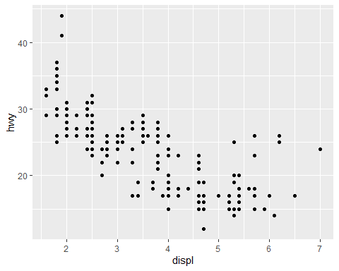

1. Facet by class with two rows.

c+ geom_point()+ facet_wrap(vars(class),nrow =2)

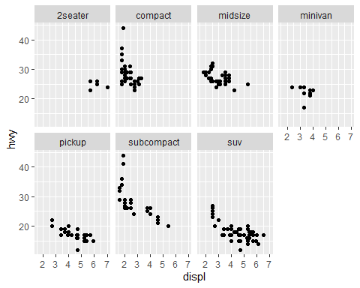

1. Facet by class and cyl

c+ geom_point()+ facet_wrap(vars(class,cyl),nrow =2)

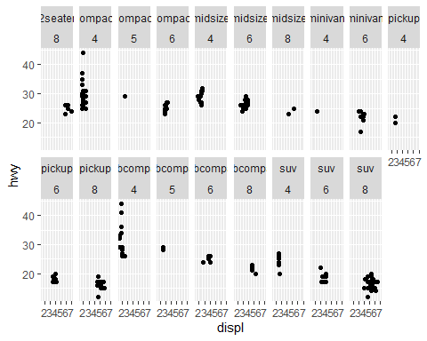

1. From your plot in #4, give any three observations.

* Cars with lower displacement generally get better mpg on a highway
* SUV and Pickups with 8 cylinders tend to have the highest displacement and concurrently the lowest mpg on a highway
* Most cars with similiar displacement less than 3 get the same mpg on a highway on average.